Chapter 3 Question 6 - Michael Streyle

##   
## Call:  
## lm(formula = hardness ~ time)  
##   
## Residuals:  
## Min 1Q Median 3Q Max   
## -5.1500 -2.2188 0.1625 2.6875 5.5750   
##   
## Coefficients:  
## Estimate Std. Error t value Pr(>|t|)   
## (Intercept) 168.60000 2.65702 63.45 < 2e-16 ***  
## time 2.03438 0.09039 22.51 2.16e-12 ***  
## ---  
## Signif. codes: 0 '***' 0.001 '**' 0.01 '*' 0.05 '.' 0.1 ' ' 1  
##   
## Residual standard error: 3.234 on 14 degrees of freedom  
## Multiple R-squared: 0.9731, Adjusted R-squared: 0.9712   
## F-statistic: 506.5 on 1 and 14 DF, p-value: 2.159e-12

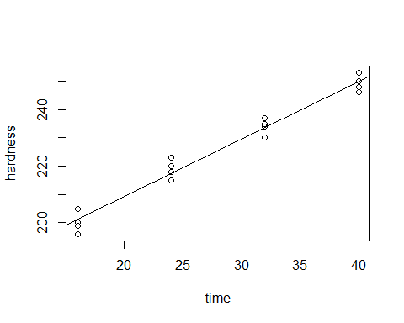

##   
## R SQUARED:

## [1] 0.9731031

##   
## CORRELATION COEFFICIENT:

## [1] 0.9864599

